Local and FTP YUM Repository Setup

Overview
It helps to create a local or FTP-based YUM repository on a RHEL/CentOS 8 system using package directories. This is useful for systems without internet access, enabling installation of software packages directly from a local or FTP source.

Copy Packages
First, create directories to hold the AppStream and BaseOS packages and copy them from :
Commands:
# mkdir /var/ftp/pub/AppStream
# mkdir /var/ftp/pub/BaseOS

# cp -rv AppStream/Packages /var/ftp/pub/AppStream/
# cp -rv BaseOS/Packages /var/ftp/pub/BaseOS/
Explanation:
- mkdir: Creates directories for storing packages.
- cp -rv: Copies the Packages directories from the mounted to the FTP directory while showing progress.

Install createrepo
If the 'createrepo' tool is not installed, install it along with dependencies:
# cd /iso/AppStream/Packages
# rpm -ivh createrepo_c-0.11.0-1.el8.x86_64.rpm createrepo_c-libs-0.11.0-1.el8.x86_64.rpm drpm-0.3.0-14.el8.x86_64.rpm
Once installed, create the repository metadata:
# createrepo -v /var/ftp/pub/AppStream/Packages/
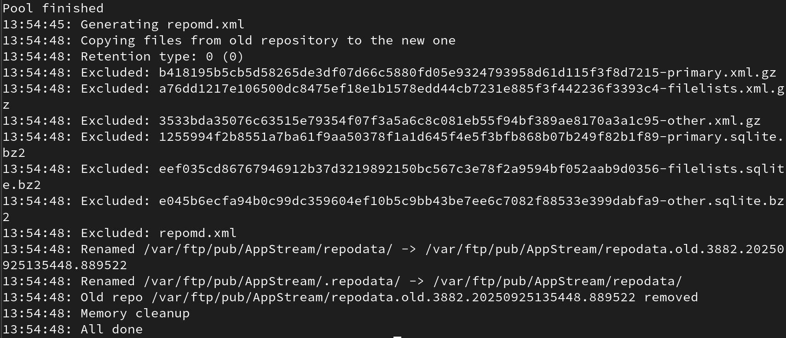
# createrepo -v /var/ftp/pub/BaseOS/Packages/
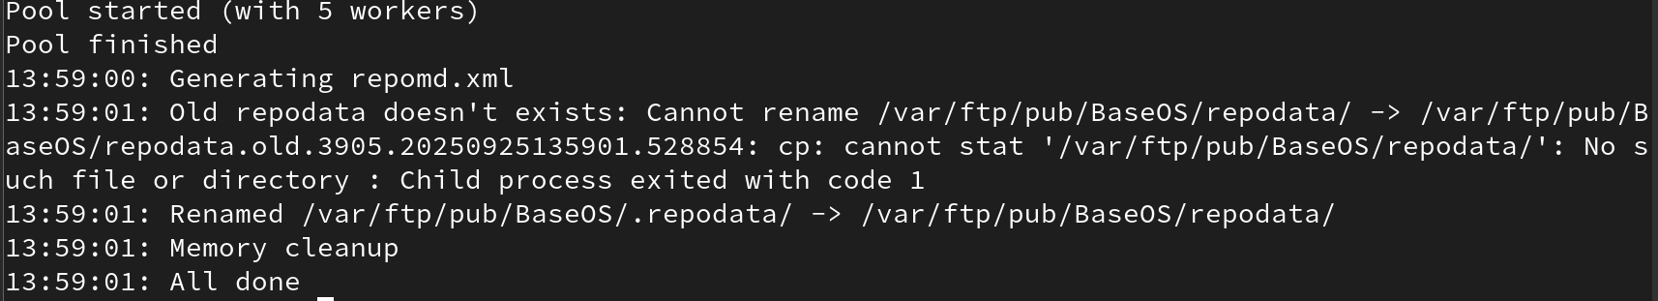
Explanation:
- rpm -ivh: Installs RPM packages.
- createrepo: Generates the required metadata for the YUM repository.

Create Repository Configuration File
Create a .repo file inside /etc/yum.repos.d/ to define the repository:
# cd /etc/yum.repos.d
# vi local.repo
Add the following content:
[Localrepo_BaseOS]
name=Localrepo_BaseOS
baseurl=file:///var/ftp/pub/BaseOS/Packages
enabled=1
gpgcheck=0
[Localrepo_AppStream]
name=Localrepo_AppStream
baseurl=file:///var/ftp/pub/AppStream/Packages
enabled=1
gpgcheck=0
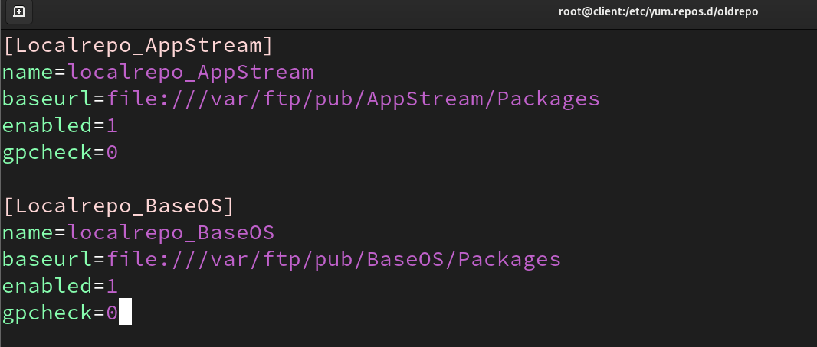
Explanation:
- baseurl: Points to the local directory where the packages are stored.
- enabled=1: Enables the repository.
- gpgcheck=0: Disables GPG key checking for simplicity.
And clear cache:
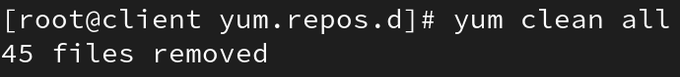
And then install package:
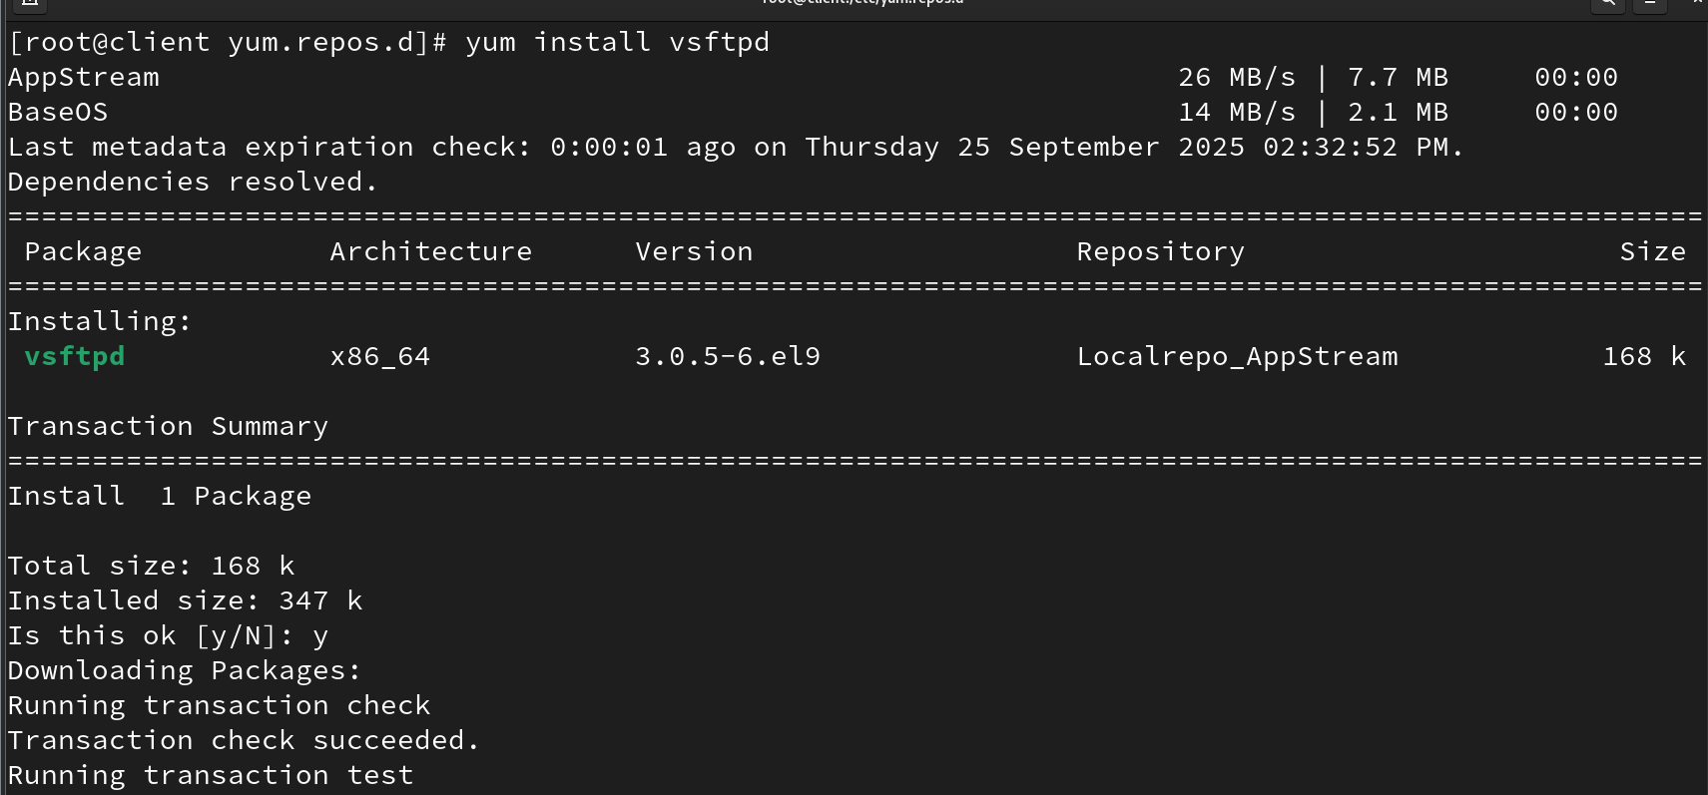
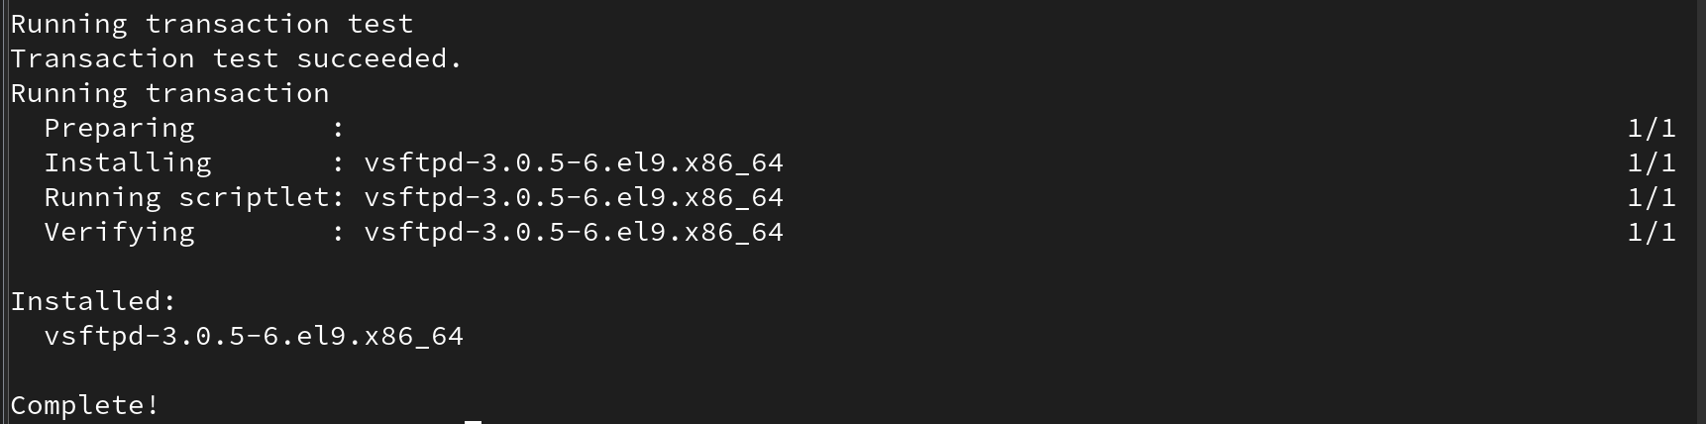

Optional: FTP-based Repository
If serving packages over FTP:
# vi /etc/vsftpd/vsftpd.conf
Set 'anonymous_enable=YES' to allow anonymous access.
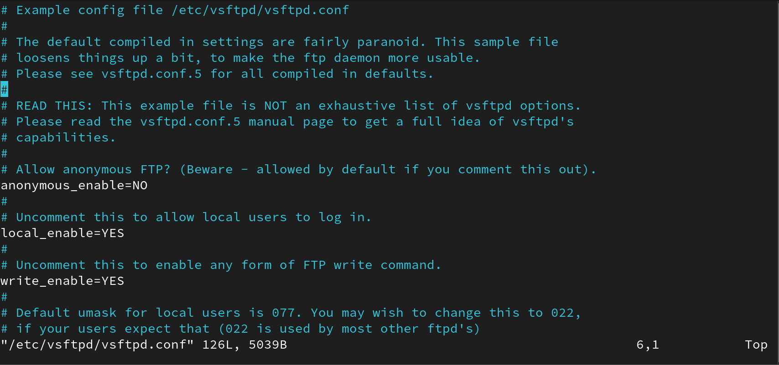
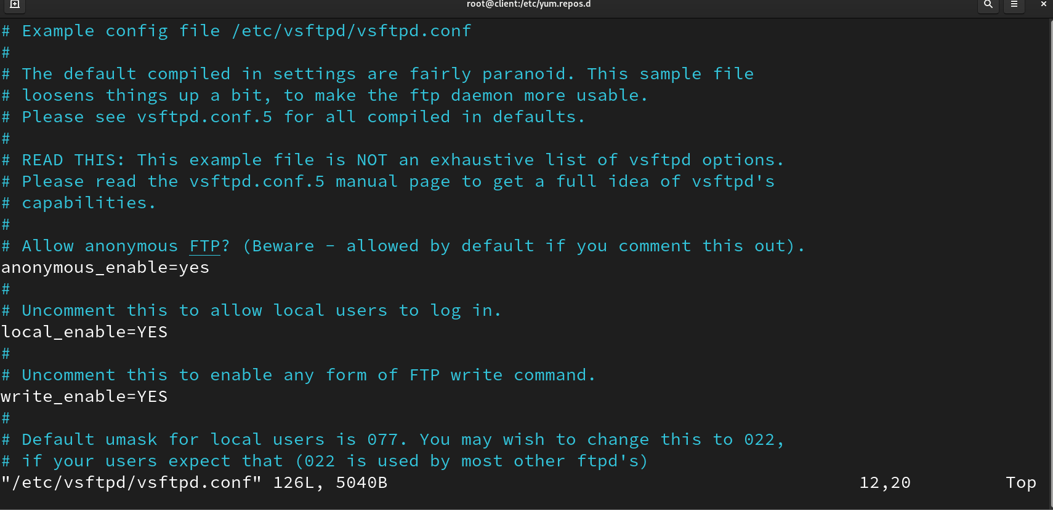

Now you have to turnoff firewall:
#systemctl disable –now firewalld.service
#setenforce0
And enable vstfpd:
#systemctl enable --now vstfpd

And then create a directory on clint mechine to install packages from server:
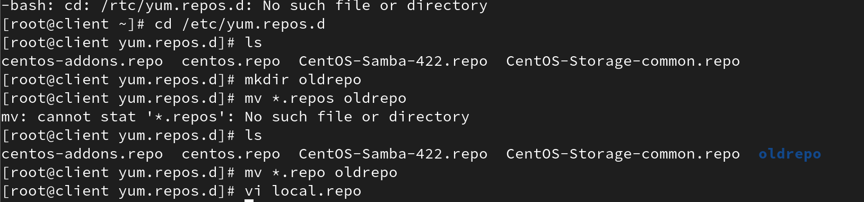
# systemctl start vsftpd; systemctl enable vsftpd
Create FTP repo entries:
[FTPrepo_BaseOS]
name=FTPrepo_BaseOS
baseurl=ftp://192.168.170.165/pub/BaseOS/Packages
enabled=1
gpgcheck=0
[FTPrepo_AppStream]
name=FTPrepo_AppStream
baseurl=ftp://192.168.170.165/pub/AppStream/Packages
enabled=1
gpgcheck=0
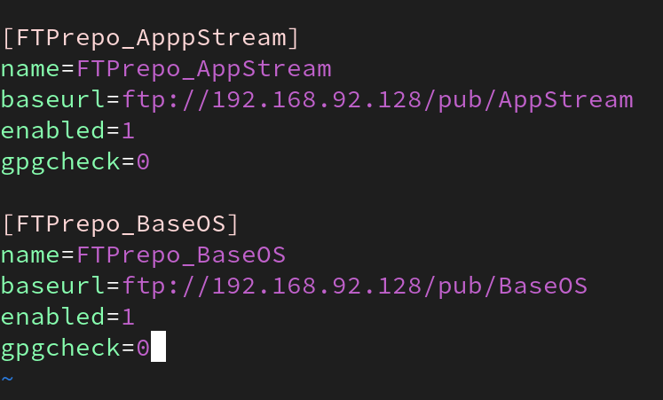
Explanation:
- vsftpd: Installs FTP server.
- baseurl: Uses FTP URL pointing to the server's IP and package path.

And install the package on client mechine:
# yum install vsftpd
